Automatic Number Plate Detection and Recognition with EasyOCR

SETUP GUIDE

24/03/2023

Table of Content

1. Introduction
1.1 Overview
1.2 Purpose of using the software
2. Pre-installation Requirements
2.2 Hardware Requirements
2.3 Software Requirements
3. Installation instructions and steps
3.1 Installation Steps
3.2 Configuration Settings
4. Possible obstacles List and Solution
5. Unistallation Procedure
6. Version History

1. Introduction

Software setup guide for Automatic Number Plate Detection using TensorFlow and Recognition with EasyOCR!
This guide will walk you through the necessary steps to set up the software for automatic number plate detection using TensorFlow and recognition using the EasyOCR library. With this software, you can quickly and accurately detect and recognize license plates in images and videos, making it useful for a wide range of applications, from traffic monitoring to security surveillance.
TensorFlow is a powerful open-source machine learning library that can be used for a variety of applications, including computer vision. In this guide, we will utilize TensorFlow to build a deep learning model that can detect license plates in images and videos.
Once we have detected license plates, we will use the EasyOCR library to recognize the characters and digits on the plate. This library utilizes state-of-the-art deep learning algorithms to recognize characters with high accuracy.
The EasyOCR library is a powerful tool that utilizes state-of-the-art deep learning algorithms to recognize characters and digits in license plates with high accuracy. Additionally, this library is open-source and can be easily integrated into your existing software projects.
In this guide, we will cover the installation and setup process for both TensorFlow and EasyOCR, as well as provide a brief overview of how to build the deep learning model using TensorFlow and how to use the EasyOCR library to recognize characters on license plates.

1.1 Overview
Brief :
Automatic Number Plate Detection and Recognition system that utilizes TensorFlow for license plate detection and EasyOCR for character recognition. This software can be used to detect and recognize license plates in images and videos with high accuracy and speed.

Purpose :
The purpose of this software is to provide a reliable and efficient solution for license plate detection and recognition in various applications such as traffic monitoring, parking management, and security surveillance. With the ability to quickly and accurately detect and recognize license plates, this software can improve efficiency and accuracy in these areas.
This version utilizes TensorFlow 2.12 and TensorFlow-Gpu 2.12 and EasyOCR 1.6.2. This version includes features such as real-time license plate detection and recognition, the ability to process multiple images and videos simultaneously, and a user-friendly interface for easy use.

Flow Diagram :

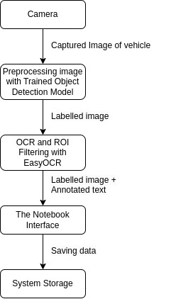

2. Pre-installation Requirements
Before installing the software, please make sure your system meets the following requirements:

2.2 Hardware Requirements

Hardware Requirements | Details
CPU | Intel Core i5 or higher with 2.0 GHz or faster
RAM | 8 GB or higher
Hard Disk Space | 20 GB or higher
Graphics Card | NVIDIA GeForce GTX 1050 or higher (for improved performance)
Display | 1280 x 800 resolution or higher

2.3 Software Requirements

Software Requirements | Details
Operating System | Windows 10 or later, or Linux
Python | Version 3.10
TensorFlow/TesorFlow-GPU(for gpu system) | Version 2.12
EasyOCR | Version 1.6.2
OpenCV | Version 4.5 or higher
NumPy | Version 1.19 or higher
Matplotlib | Version 3.3 or higher
CUDA(For gpu system) | Version 11.2
cuDNN(For gpu system) | Version 8.1
Nvidia Driver Version(for gpu system) | Version 525
Torch | Version 2.0
Web Browser | Google Chrome, Mozilla Firefox, or Safari
Other | Internet connection

3. Installation instructions and steps
To install the Automatic Number Plate Detection and Recognition software, please follow the steps below:
Gameplan:
1. Install and Setup
2. Getting Licence Plate Data
3. Training a Object Detection Model
4. Detecting Licence Plates
5. Applying OCR to Text
6. Output ROIs and Results

3.1 Installation instructions and steps

Step 1:(Optional, If you have gpu enabled system) Setting up your pc for CUDA and cuDNN Libraries which will be used in this project as Tensorflow-gpu will require Dynamic Libraries which will accelerate the speed.
For that refer CUDA and cuDNN Setup Document
Step 2: Git clone
https://github.com/nicknochnack/TFODCourse
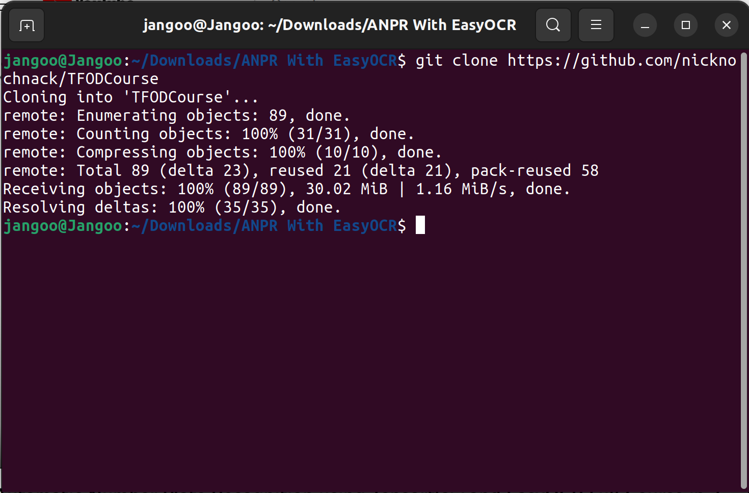

Step 3: Then install EasyOCR libraries in your system with command
!pip install easyocr

Step 4: Create a new venv Python Virtual Environment inside the git cloned TFODCourse Folder
python -m venv anprsys

This will create Local Virtual Environment and folder inside your TFODCourse Folder
Now activate the Virtual Environment with command

source anprsys/bin/activate

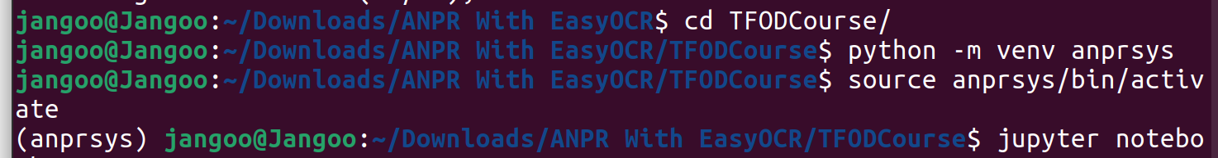
It will activate Virtual Environment for your project which will be isolated from your system

Step 5: Upgrade Pip inside Virtual Environment
python -m pip install --upgrade pip

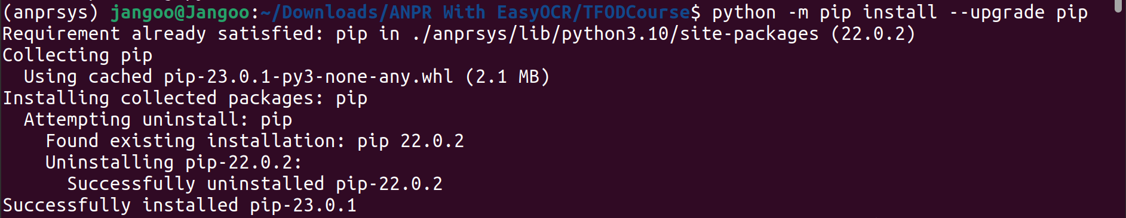
Step 6: Install ipykernel

pip install ipykernel

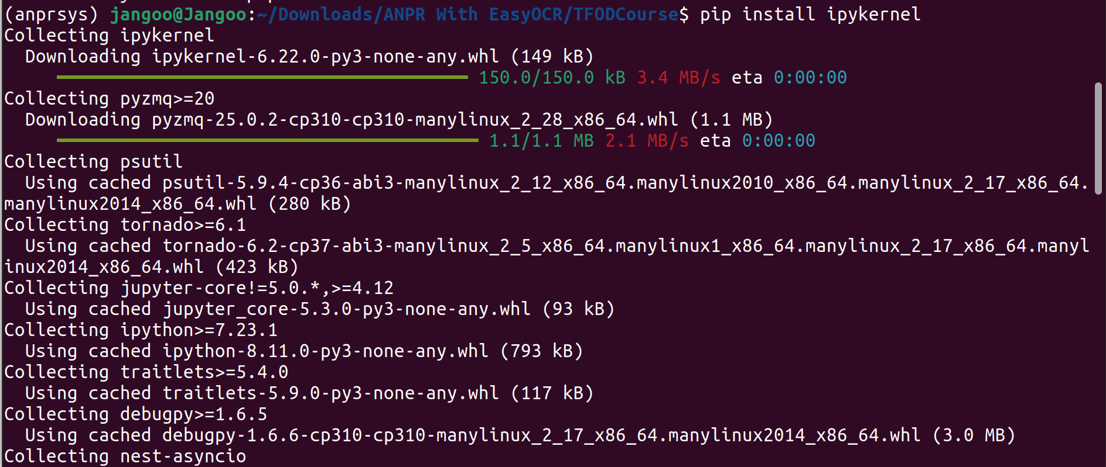

Step 7: Install Jupyter Notebook inside venv

pip install notebook

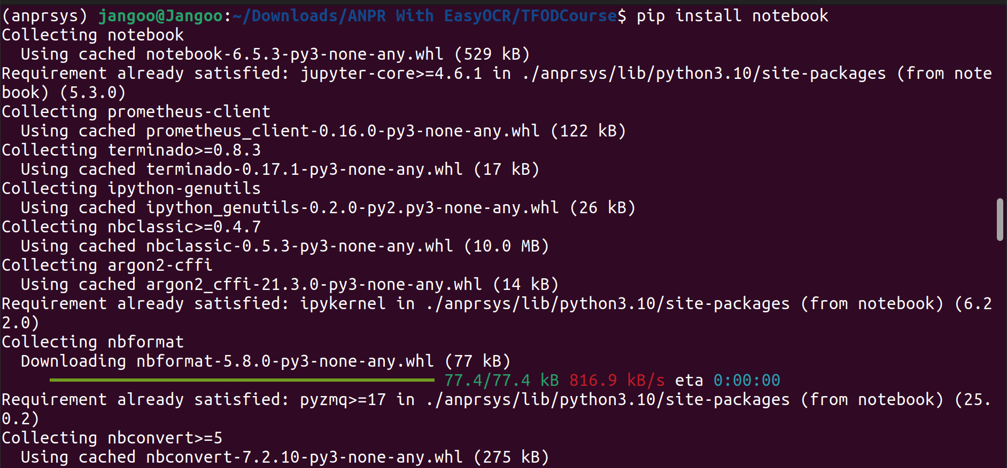
Step 8: Adding ipykernel to our venv anprsys and launching Jupyter notebook

python -m ipykernel install --user –name=anprsys
then launch the jupyter notebook with command jupyter notebook, It will open your jupyter notebook GUI in chrome window.

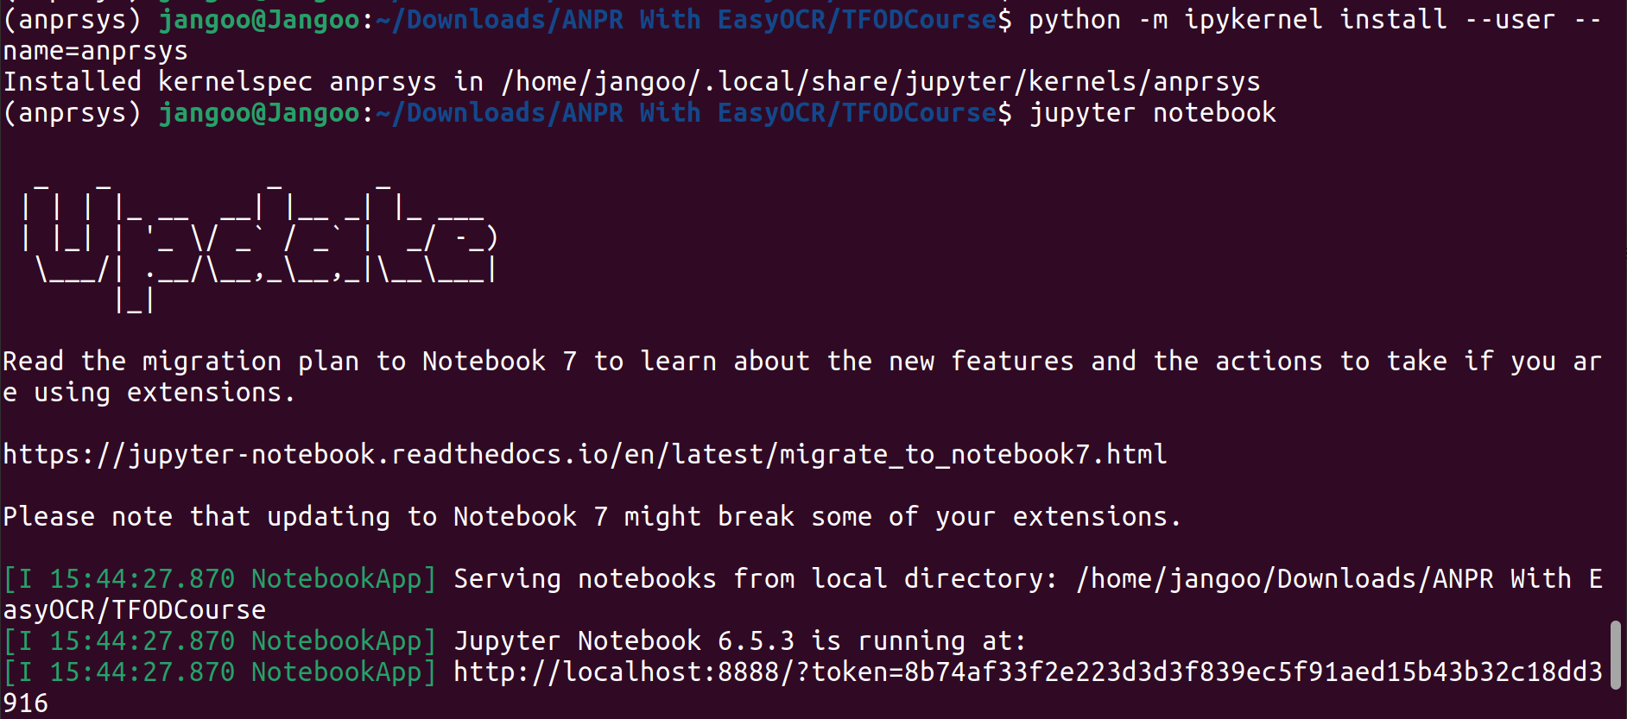
Step 9: Open Training and Detection.ipynb and Select Kernel anprsys

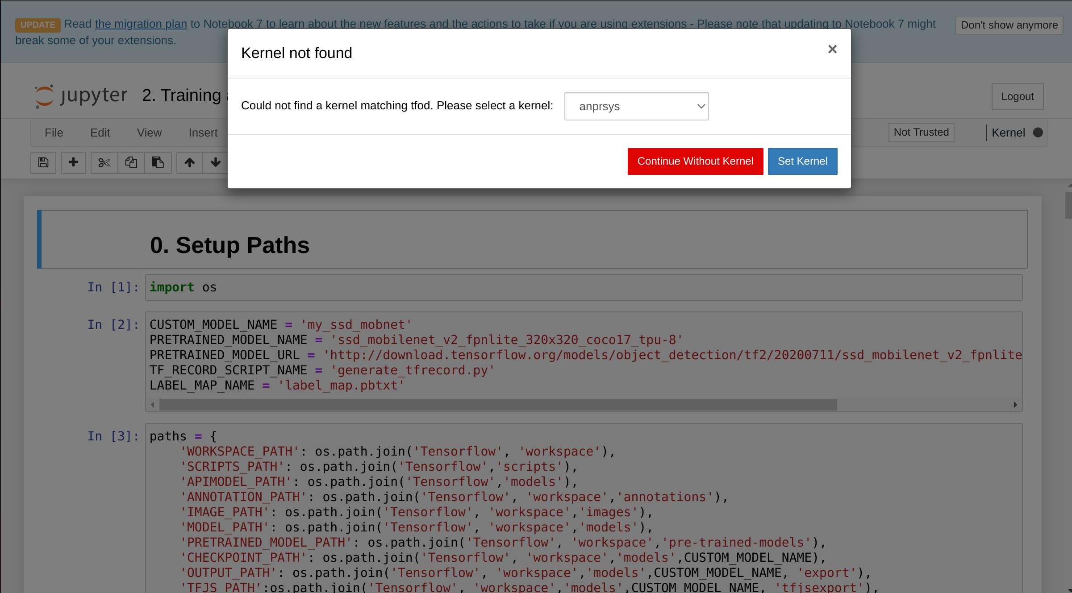
and click on Not Trusted on top right corner and select and select Trust to trust this notebook.
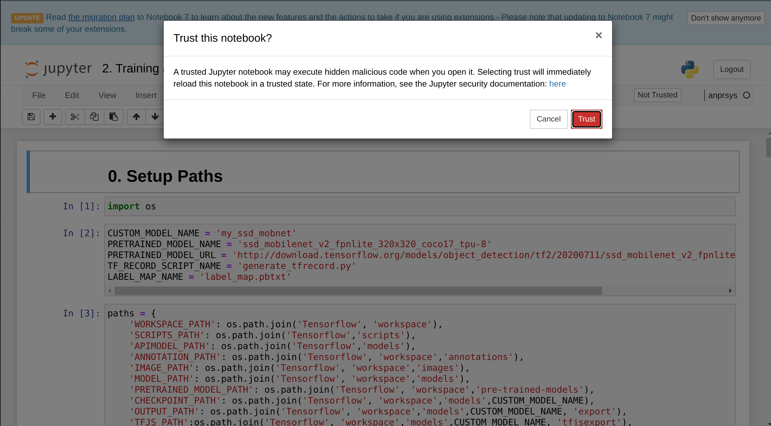

Step 10: Clear all output before starting with project

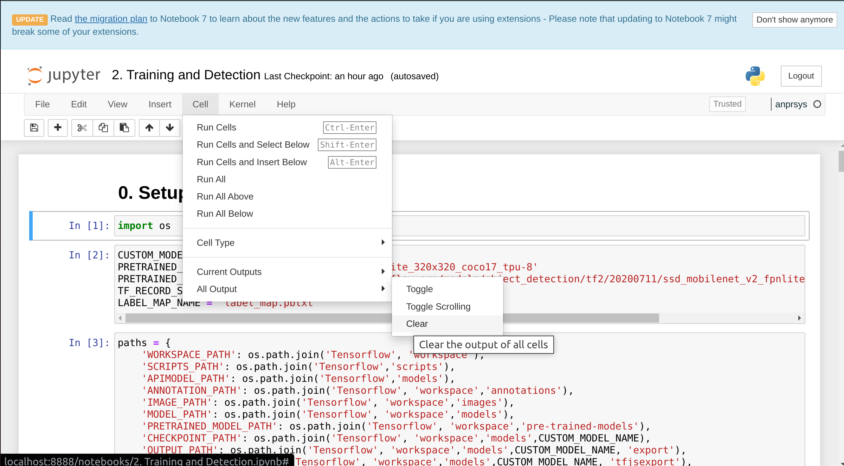
Step 11: Run every cell in 0. Setup Paths with Shift + Enter it will run that cell and go forward to next cell.

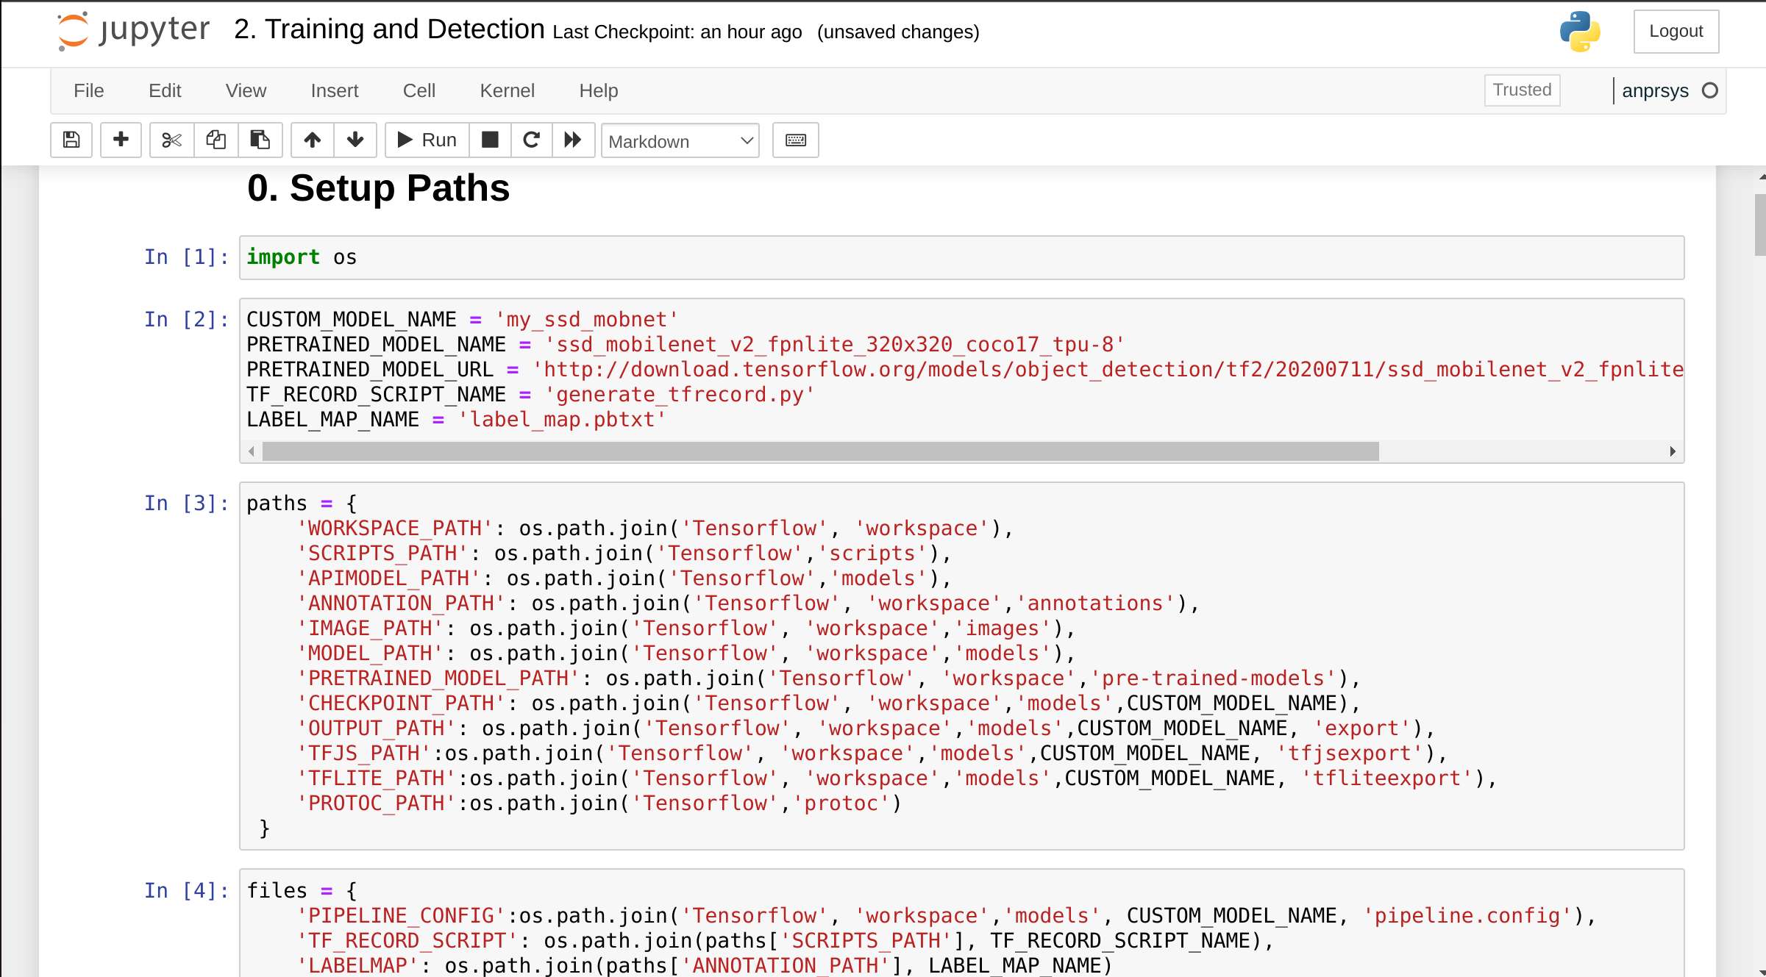
It will create import os and detect os we are working on create Directory Tensorflow inside the TFODCourse and required directories for it.
Step 12: In 1. Download TF Models Pretrained Models from Tensorflow Model Zoo and Install TFOD

Run first and second cell, first cell is to import wget which is a computer program that retrieves content from web servers and second one clones tensorflow models inside the Tensorflow folder which was created

Before running 3rd cell add !pkexec before apt-get as it will throw permission denied erorr and ask for root permission for downloading it.

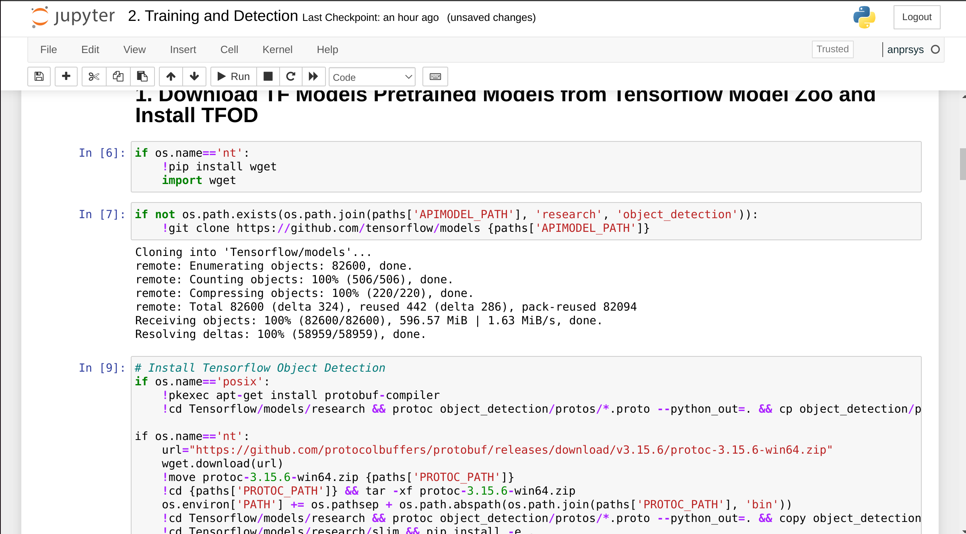

Adding pkexec works as sudo and promp to add password to provide root access to the user
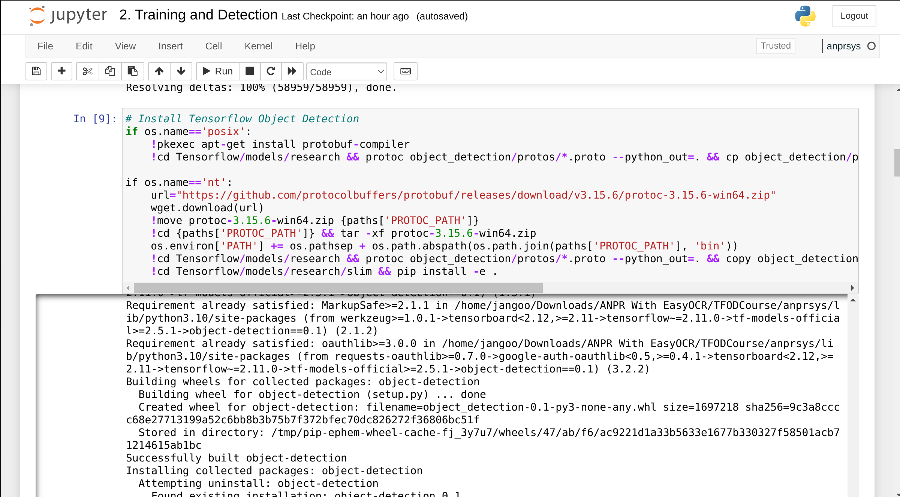

It will install tensorflow and other required libraries with it. You can check Packages and version by running !pip list which will list all the library present in the venv

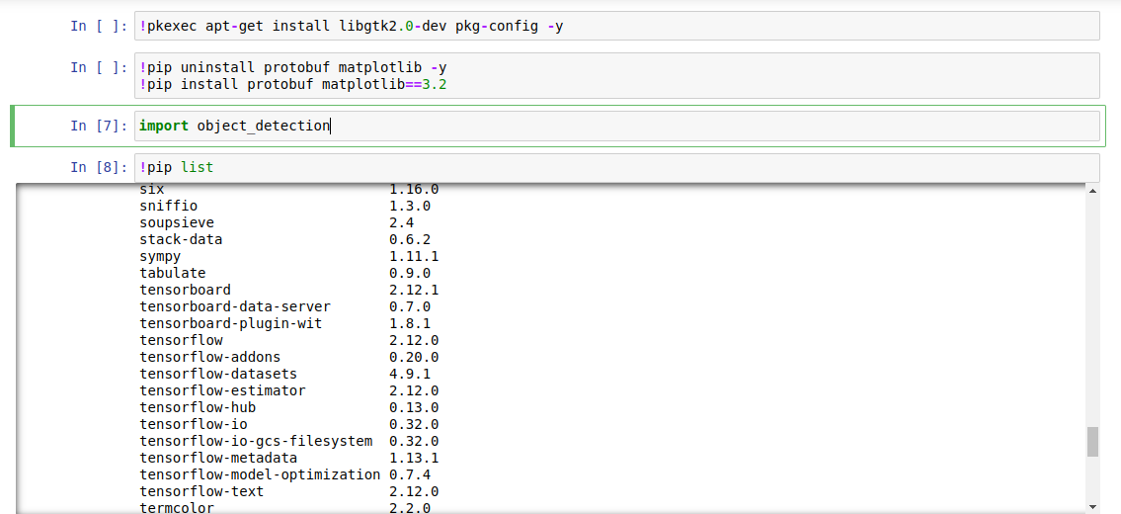

But tensorflow-gpu will not be installed with it which is optional for this project if you want to use gpu acceleration with your object detection and recognition, If you want to use prease refer to CUDA and cuDNN Setup Document
*This is Tensorflow CPU compatibilty list with Python and C++(Which is used for this project)

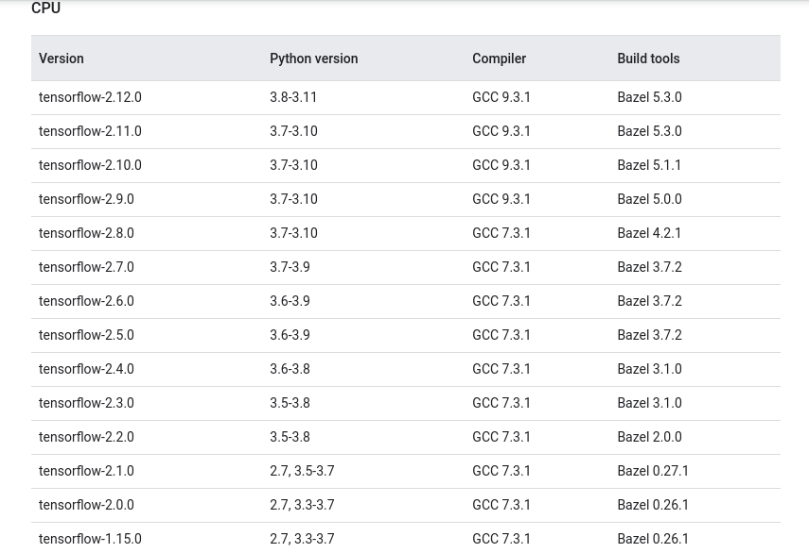

Step 13: Install Tensorflow-gpu with CUDA and cuDNN (Optional, only if you have gpu enabled system)

For installing tensorflow-gpu it should be similar to version of Tensorflow which is installed Tensorflow version installed for this instance is 2.12.0 so Tensorflow-gpu version should also be 2.12.0 .

for that refer to this link to install CUDA and cUDNN:

https://www.tensorflow.org/install/source

This is Tensorflow GPU compatibilty list with CUDA, cuDNN, Python and C++ and Bazel

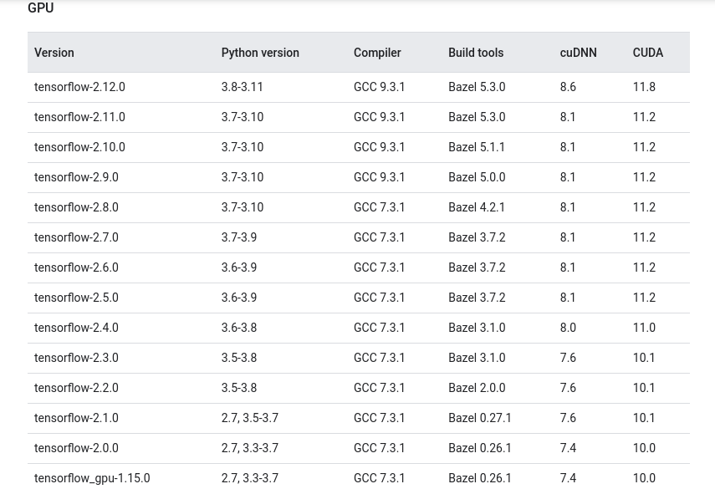

This is the compatibilty list of CUDA and cuDNN with Tensorflow and Python version. It is very crucial to match the version with the system for Tensorflow to work with GPU and be CUDA enabled and refer to CUDA and cuDNN Setup Document for seting up GPU computation.

For current version of Demo i am using Python – 3.10 and Tensorflow-CPU - 2.12

Step 15: Run Verification Script to verify installation to check if everything required is installed or not.

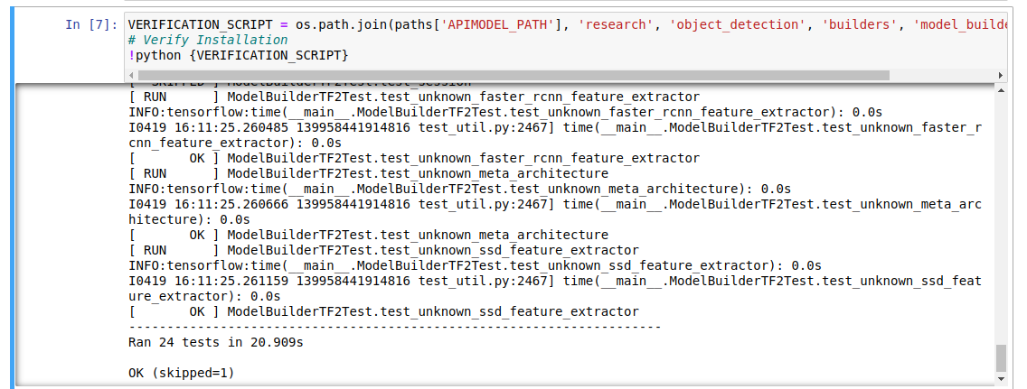
Step 16: Run command to import object detection
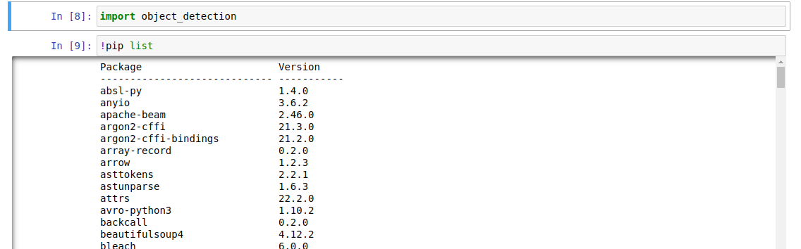
If you face any issue running this command, restart the kernel then try it again.

Step 17: After that run command to check the operating system and downloads a pre-trained model from a specified URL. If the OS is POSIX (e.g. Linux or macOS), it uses wget and tar to download and extract the model files.

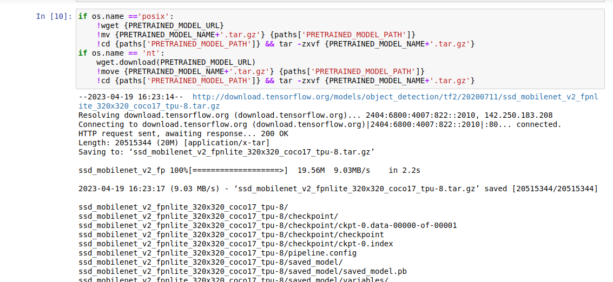
Step 18: Downloading Dataset which will be used to train the Tensorflow model from kaggle
https://www.kaggle.com/datasets/andrewmvd/car-plate-detection

Extract this in this directory inside Tensorflow Folder inside ANPR and divide it into test and train folder.

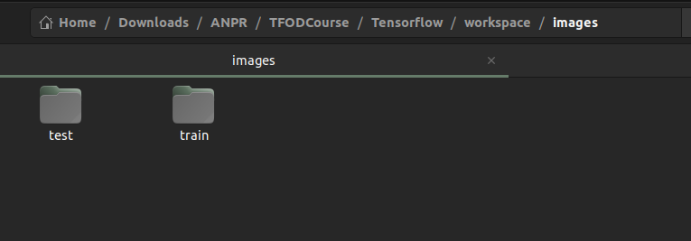

For this demo i have split the 433 total images and xml files into train folder(410 image & 410 xml files) and test folder(22 images & 22 xml files)

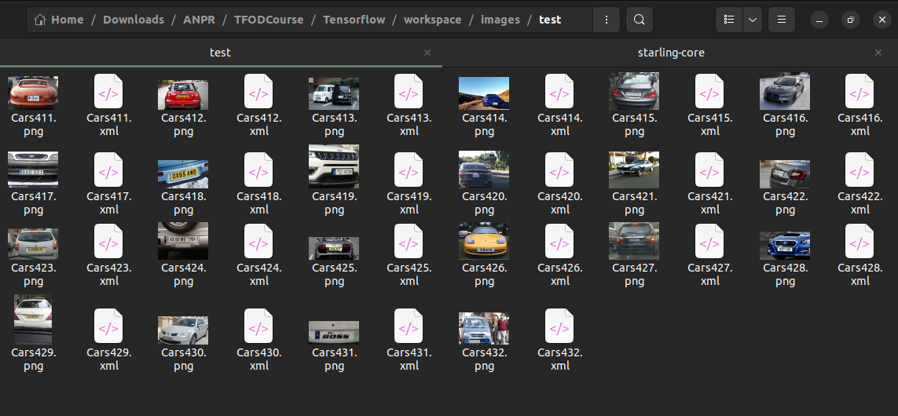
Step 19: Creating Lables Map from the data by creating a new file in location Tensorflow/workspace/annotations named label_map specifies that it will be used for writing. It then writes each label and its ID to the file in a specific format that is commonly used for label maps in machine learning models.

*Make sure to check the name licence matches name written in xml file

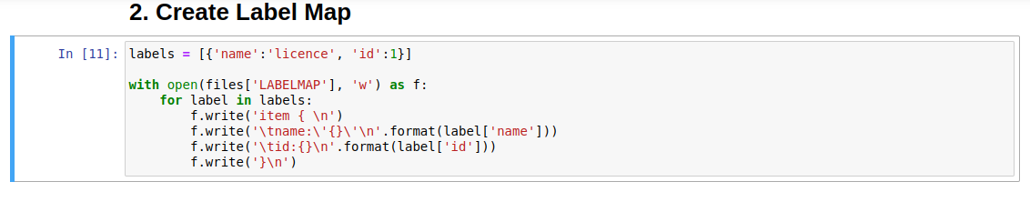
Step 20: Creating TF records from the labels map

Generates TensorFlow Record files from image and annotation data using a Python script names test.record and train.record in the same location as label_map
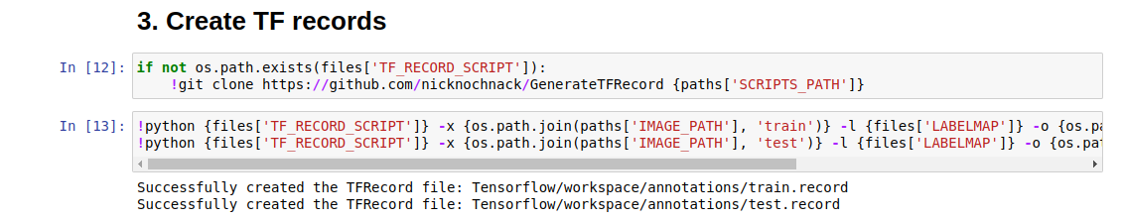
While running this command you may come up with error:

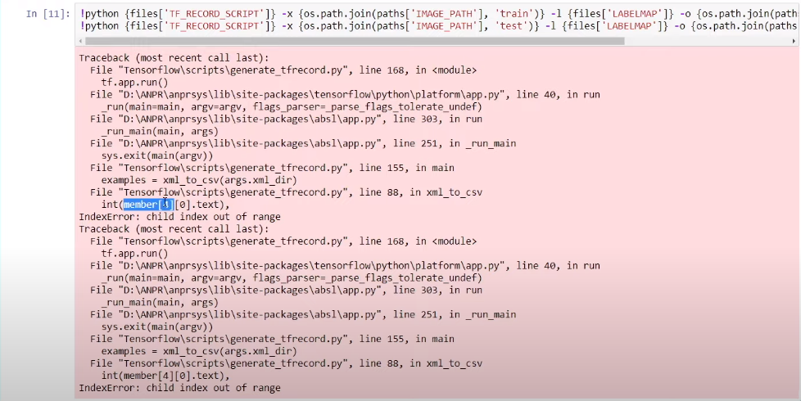

To fix this error modify the file generate_tfrecord.py in the location Tensorflow/scripts just replace integer 4 with 5 at line 88-91 :
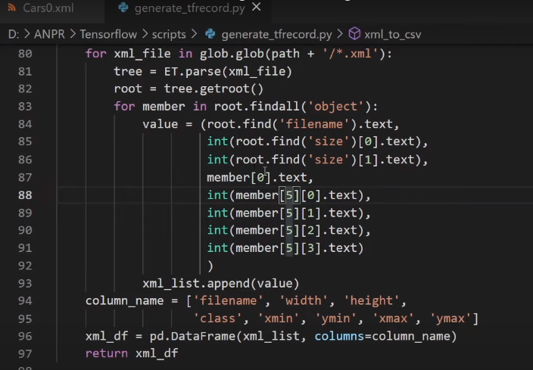
This will fix the issue

Step 21: Copy config file to the training folder by running code in this cell

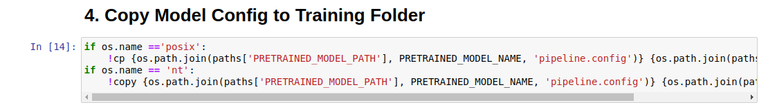
Step 22: Update config file location with the current location from default for directories
For this run every cell inside 5. Update Config For Transfer Learning

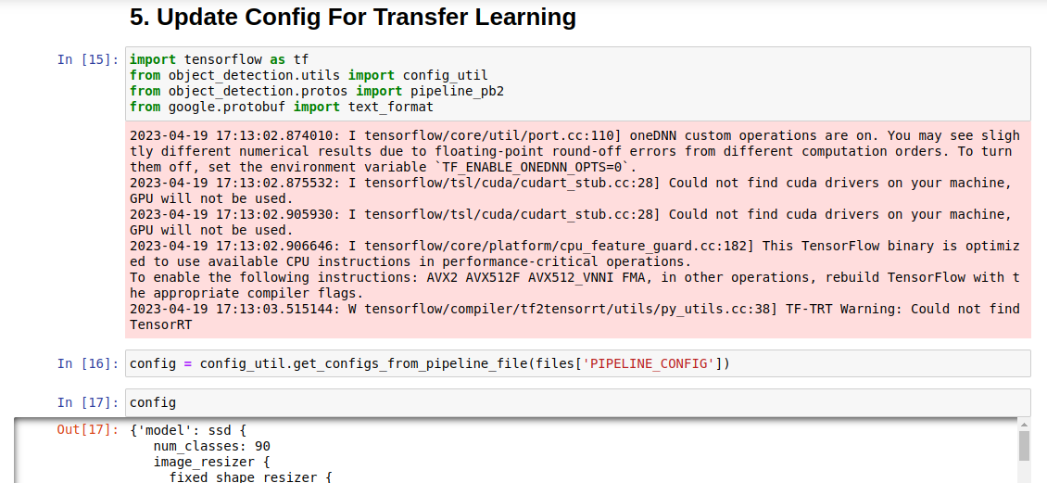
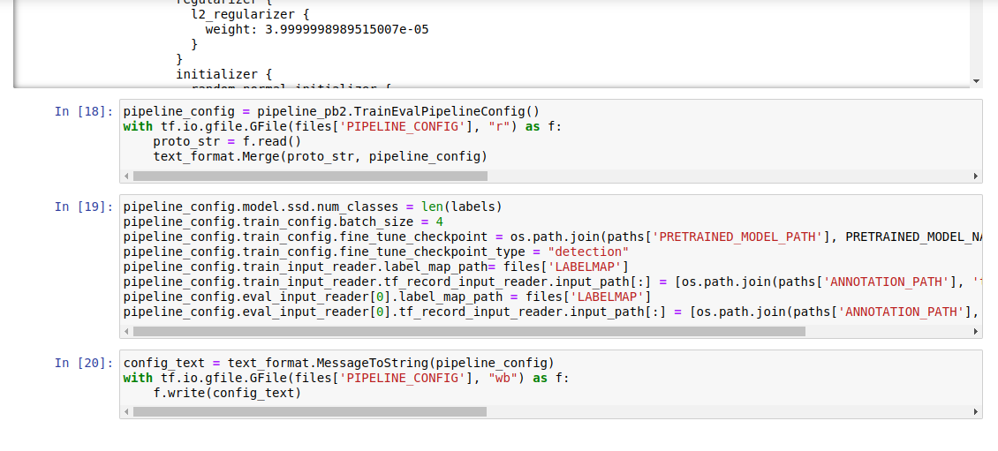
Step 23: Training the Tensorflow Object Detection Model to detect Number Plates on a vehicle

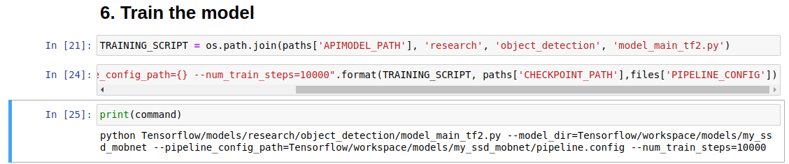
Running this cell will produce the code which will be used to train the machine learning model
*Now, open new terminal in same location and activate virtual env in it by typing source anprsys/bin/activate to activate the virtual env we are working in.

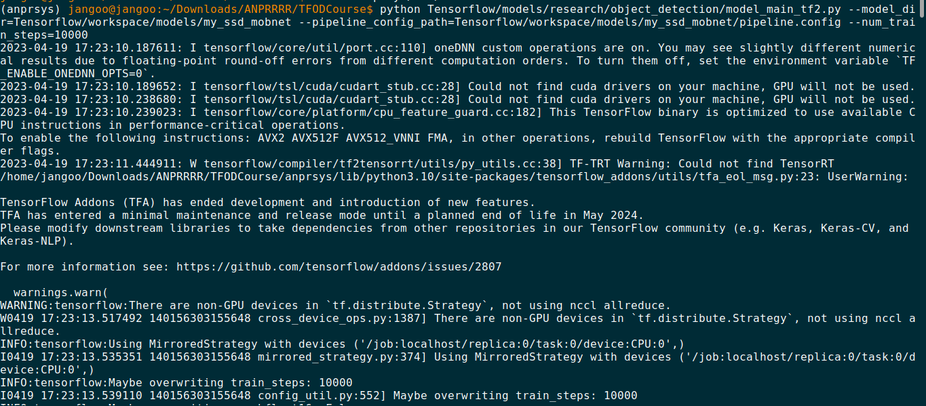
Training Command Generated for 10000 Steps:

python Tensorflow/models/research/object_detection/model_main_tf2.py --model_dir=Tensorflow/workspace/models/my_ssd_mobnet --pipeline_config_path=Tensorflow/workspace/models/my_ssd_mobnet/pipeline.config --num_train_steps=10000

It will start training it for 10000 steps which will create trained model files inside directory Tensorflow/workflow/models/my_ssd_mobnet

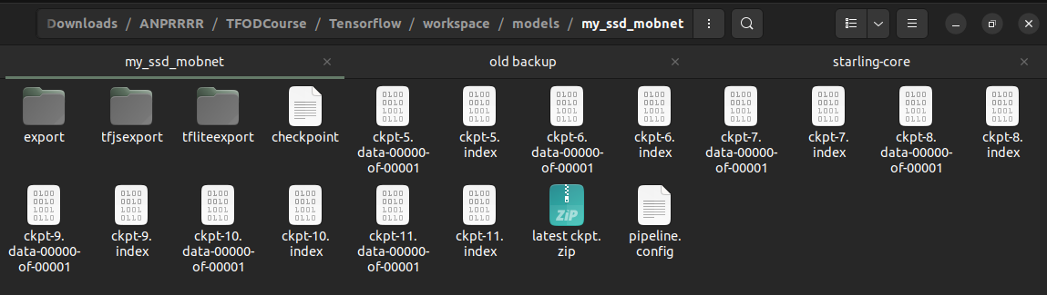
The ckpt files are the trained models which will be used for object detection.

Step 24: Now we will detect Number Plate for that first we will load functions that are essential for performing object detection using a pre-trained detection model in the TensorFlow 2 Object Detection API. The functions load a pipeline configuration file, build a detection model, restore the model's previously saved weights, and define a detect_fn function that uses the model to perform object detection on input images. These functions work together to set up a pipeline for object detection using a pre-trained model, which can be further customized and extended for specific use cases.

Run both cells in 8. Load Train Model From Checkpoint:

Which will load our trained model ckpt-11 for object detection

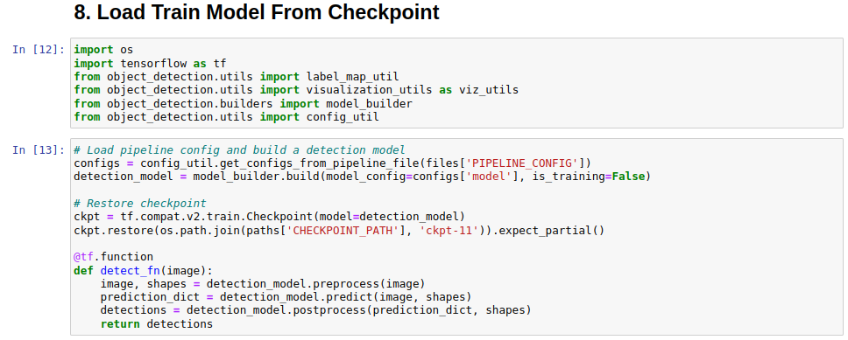
Step 25: Testing our Tesorflow object detection trained model on images

Run every cell in 9. Detect from an image just modify the image name in image_path accordingly

In this case i am using image Cars411.png from test folder inside Tensorflow/workspace/images/test

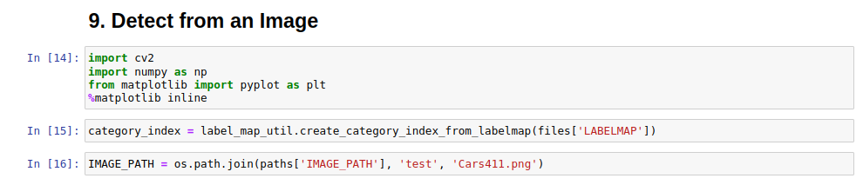

Then after running every cell it should output :

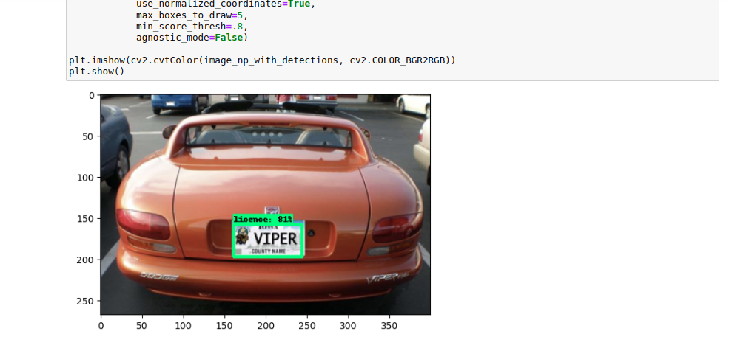
The 2 cells after this which have code detections.keys() and detections

detections is a dictionary containing the output of the detect_fn function, which represents the results of object detection performed by the detection model. The keys of the dictionary represent the names of the detection output tensors, and the values are arrays containing the corresponding tensor values.

detections.keys() returns a list of the keys in the detections dictionary, which can be used to access specific detection output tensors. For example, detections[‘detection_boxes’] would return an array containing the bounding box coordinates of the detected objects. Similarly, detections[‘detection_classes’] would return an array containing the class labels of the detected objects.
detections and detections.keys() provide a convenient way to access the output of the detection model and extract information about the objects detected in an input image.
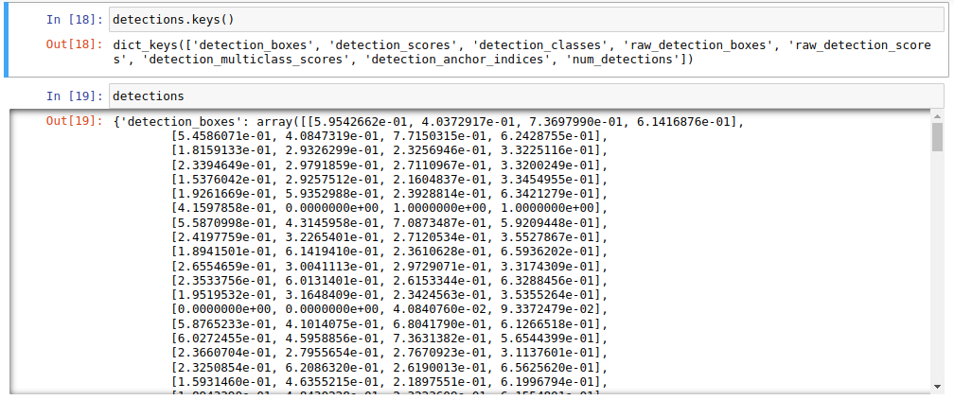
Step 26: Real Time object detection from webcam
Now after testing our Tensorflow object detection model on image we can test it on real time video stream provided with OpenCV by running the cell in 10. Real Time Object Detections from your Webcam

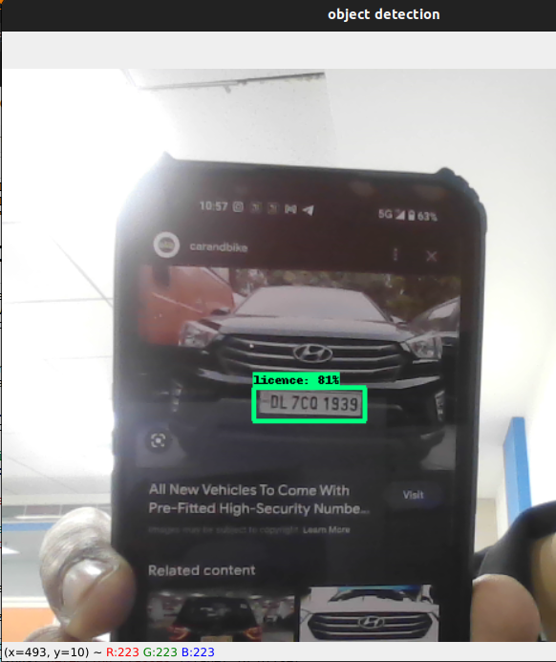

Step 27: Applying Optical Character Recognition Filtering and ROI Filtering (Region Of Intrest) to the detected image
For that applying OCR Filtering and ROI Filtering to the

- First install easyOCR inside our virtual environment.
- Importing easyocr.
- Set detection_threshold which will be taking detected image with prediction above set limit.
- Set region_threshold which is a parameter used in object detection algorithms to filter out redundant or overlapping detections.
- Next cell is defining the function filtered_text which takes in a region of an image, the result of an optical character recognition (OCR) operation on that region, and a region_threshold value. It filters the OCR results based on the proportion of the region covered by the detected text, and returns the text that covers at least region_threshold proportion of the region.
- Next cell is defining the function ocr_it which takes detected image, object detection results, detection and region thresholds as input. It applies ROI filtering and OCR to the detected regions in the image, and returns the filtered text and region image.
- Next code cell prints out the ROI filtered image and OCR result from it.

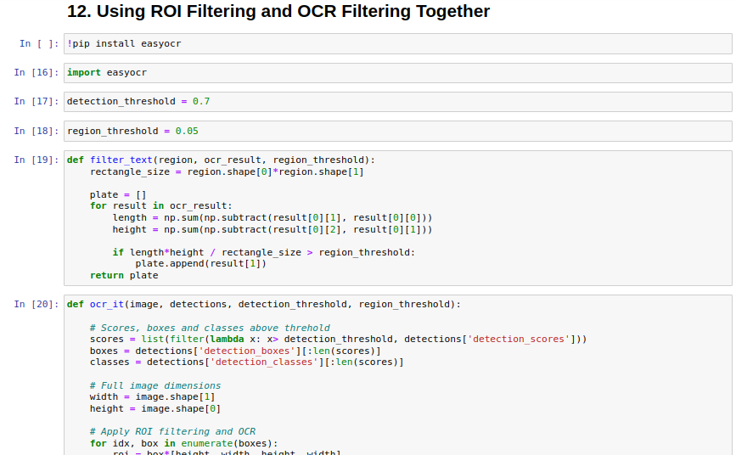
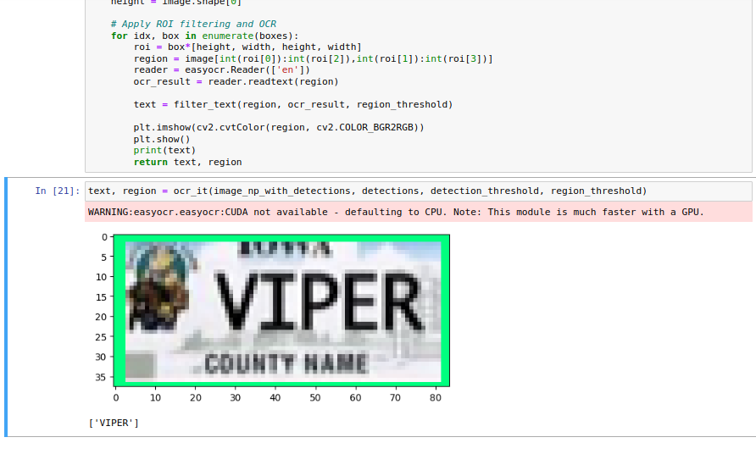
Step 28: Using Number Plate Detection and Recoginition in Real Time and saving Result in realtime

To use them together run the cell 13. Using Number Plate Detection and Recoginition in Real Time and saving Result Realtime

- First cell is The code that defines a function named save_result that takes text, region, csv_filename, and folder_path as input and saves the region as an image file and the text along with the image filename to a CSV file. It also uses the uuid module to generate a unique filename for each image.

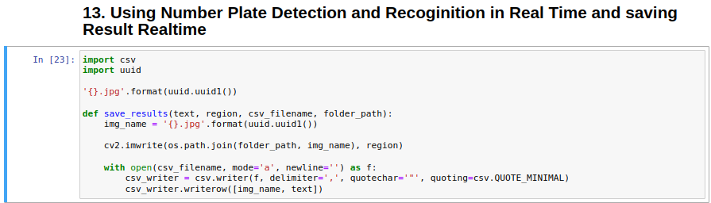

- Then run the second cell it will open the Camera for detection
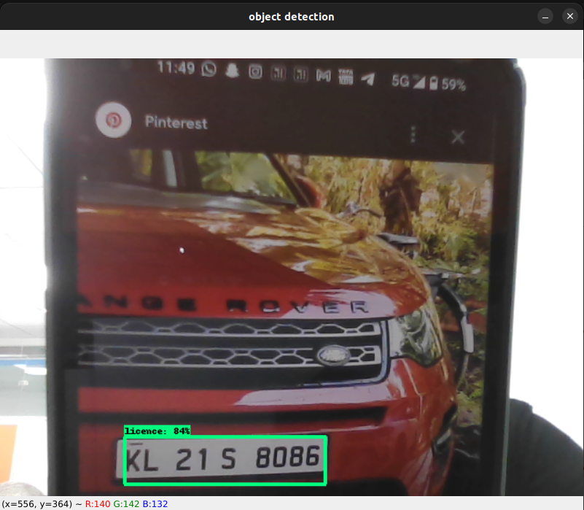
And post the Optical Character Recoginition below the code block

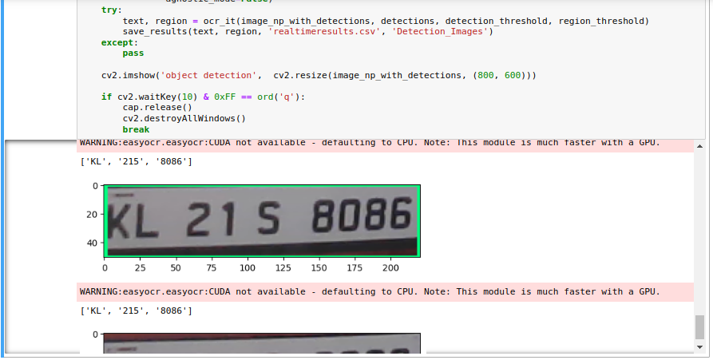

This will also save the detected image in Detection_Images in project’s path

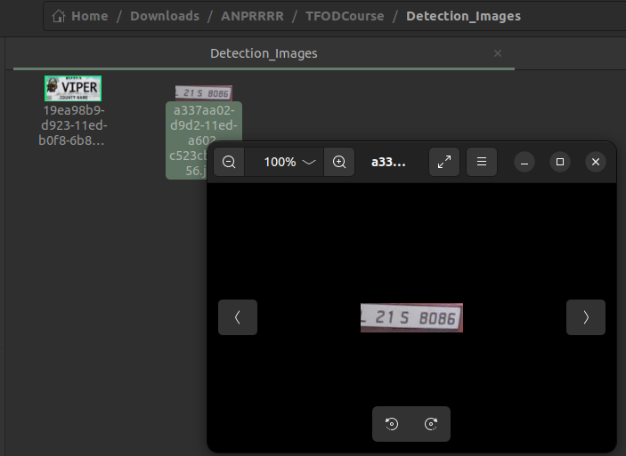

And also saves OCR result of detected image in realtimeresults.csv file

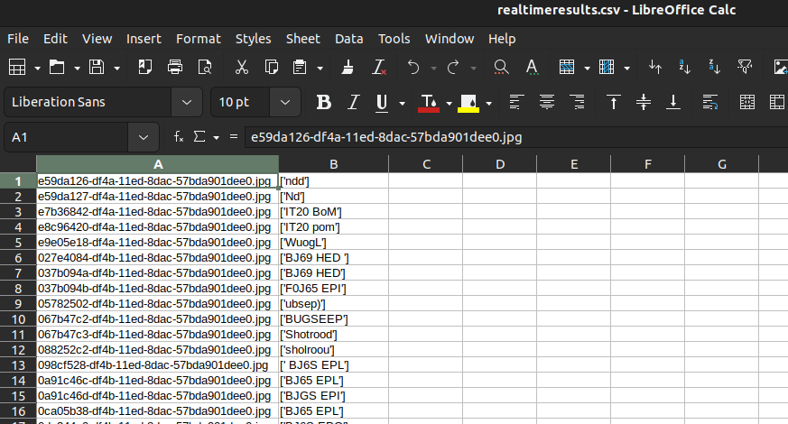

4. Possible obstacles List and solution
Error: No module named ‘xxxxxx’
Solution: Install that module
!pip install xxxxxx
Example:
Error: No module named typeguard
Solution: pip install typeguard # note the name of the module will not always equal the package name
Error: AttributeError: module 'sip' has no attribute 'setapi'
Solution: Downgrade matplotlib to version 3.2 by running the following command
!pip install matplotlib==3.2
Error: ValueError: numpy.ndarray size changed, may indicate binary incompatibility. Expected 88 from C header, got 80 from PyObject
Solution: Reinstall pycocotools
Pip uninstall pycocotools -y
Pip install pycocotools
Error: ValueError: 'images' must have either 3 or 4 dimensions.
Solution: Restart your jupyter notebook as the Webcam is unavailable. If using images, this normally means your image name and path is incorrect.
Error: (-2:Unspecified error) The function is not implemented. Rebuild the library with Windows, GTK+ 2.x or Cocoa support. If you are on Ubuntu or Debian, install libgtk2.0-dev and pkg-config, then re-run cmake or configure script in function 'cvDestroyAllWindows'
Solution: Reinstall opencv and uninstall opencv-headless
pip uninstall opencv-python-headless -y
pip install opencv-python --upgrade
Error: When running GenerateTFRecords script you receive an error like the following: File "Tensorflow\scripts\generate_tfrecord.py", line 132, in create_tf_example classes.append(class_text_to_int(row['class'])) File "Tensorflow\scripts\generate_tfrecord.py", line 101, in class_text_to_int return label_map_dict[row_label] KeyError: 'ThumbsDown' # YOUR LABEL HERE
Solution: This is likely because you mismatches between your annotations and your labelmap. Ensure that the label names from your annotations match the label map exactly, note it is case sensitive.
Error: When running training script from the command line, you get a No module error. e.g. ModuleNotFoundError: No module named 'cv2'
Solution: Remember you need to activate your environment at the command line in order to leverage all the packages you have installed in it.
Error: When training, only the CPU is used and the GPU is ignored.
Solution: Ensure you have a matching CUDA and cuDNN version for your Tensorflow version installed. Windows:https://www.tensorflow.org/install/source_windows, Linux/macOS:https://www.tensorflow.org/install/source
Refer CUDA and cuDNN Setup Document
Error: CUBLAS_STATUS_ALLOC_FAILED or CUDNN_STATUS_ALLOC_FAILED
Solution: This is because the available VRAM on your machine is completely consumed and there is no more memory available to train. Quit all of your Python programs and stop your Jupyter Notebook server to free up the VRAM and run the command again.
When the installation and configuration has been finished successfully, there might be some cleanup-tasks necessary. This could include e.g. removing the installation files, cleanup the temp folder or configure a database backup.

5. Unistallation procedure
Step-by-step instructions for uninstalling the software, Any precautions or warnings before uninstallation and post-uninstallation cleanup steps or recommendations.

Software | Uninstall Command
Removing the project files | Go outsite project folder open terminal and run Sudo rm -r ProjectName
Tensorflow Object Detection | pip uninstall tensorflow
Tensorflow-GPU | pip uninstall tensorflow-gpu
CUDA and cuDNN | sudo apt-get remove --autoremove nvidia-cuda-toolkit libcudnn8  Remove the CUDA and cuDNN files and directories.  sudo rm -rf /usr/local/cuda-<version>  sudo rm -rf /usr/local/cudnn-<version>-linux-x64-<cuda-version>
Pytorch | pip uninstall torch
jupyter notebook | pip uninstall jupyter notebook
Python Virtual Environment (venv) | deactivate  rm -rf <venv_directory>
EasyOCR | pip uninstall easyocr
Opencv | pip uninstall opencv-python

6. Version History

Version | Release Date | Description | Made by | Reviewed By
1.0 | 19/04/2023 | Initial release | Shubham | Hitanshu Punj

